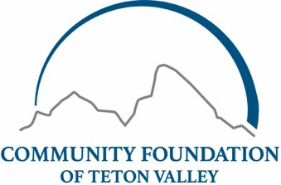
2025 FALL YOUTH PHILANTHROPY
GRANT APPLICATION FORM

Legal Name of Organization: Mission Statement of Organization:
Contact Person Name and Title:
Phone:
Email:
Organization Mailing Address:
Organization Website:
Organization Employer Identification Number (EIN#):

Project Information
Project Title:
Requested Amount ($500 to $1,500)
Project Start Date:
Project End Date:

Project budget: (Total Income vs. Expenses should net to zero)

Income | Amount | Expenses | $ Amount
Youth Philanthropy Grant Request
TOTAL $ |  | TOTAL $

Grant Application Narrative*
*Please use the format below to tell us about your project - deleting the instructive text as you go.

- Project Summary: (60 words or fewer)
Please write a brief summary of your proposal. This section should concisely tell our Youth Philanthropy students about your project.

- Community Need:
Please describe the nature, scope, and urgency of this need in our community. Please include specific data and information regarding how this issue impacts Teton Valley. *Tip: be sure to write this section from the perspective of what the community needs, not from the perspective of what your organization needs.

- Project Description:
Describe the project in detail and explain how your organization will use grant funds. What are you trying to accomplish? What are the critical components of this project? What other agencies, if any, are collaborating with you?

- Evaluation Criteria:
What criteria will you use to evaluate and measure the success of your work? How will you assess the degree to which you have impacted the community need?

Submit Application
Send completed 2025 Fall Youth Philanthropy Grant Applications to bthysell@cftetonvalley.org

Applications will be accepted from
Monday, September 29 to Friday, October 17, 2025 at 5:00pm.
Applications received outside of the grant cycle will not be considered.

